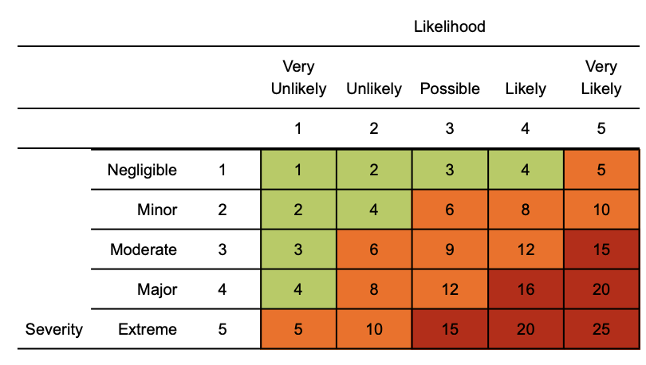
Risk matrix used in risk assessment below
RR = residual risk

Coronavirus (COVID-19) risk assessment

Assessment date:
Review date:
Completed by: Janet Moffatt
Version: 1.4

Hazard | Risk | Control measures | RR | Persons at risk
Exposure from others due to:  1) Living with someone with a confirmed case of COVID-19.  2) Have come into close contact (within 2 metres for 15 minutes or more) with a confirmed case of COVID-19.  3) Being advised by a public health agency that contact with a diagnosed case has occurred. | 4  x  3  =  12 | - To follow government action of self isolation and only to leave house on the following circumstances: for medical reason; to shop for necessary food supplies; for exercise; and for essential works including those deemed ‘key/essential workers’  - Any existing individual risk assessments (disability, young persons or new / expectant mothers) to be reviewed  - Maintain contact with line management and Janet Moffatt (HR) and to follow company policy / guidance.  - Travel is only required for essential travel; reduce the amount of time using public transport and to implement social distancing where possible (2m clearance from persons and not to travel in groups of more than 2 unless it is immediate family)  - To continue following ongoing government guidance  - Stay at home and only attend hospital in an emergency. Do not attend GP surgery and phone NHS line (111) if further advice is required  - Company to ensure extremely vulnerable persons (Solid organ transplant recipients; people with specific cancers: people with cancer who are undergoing active chemotherapy or radical radiotherapy for lung cancer; people with cancers of the blood or bone marrow such as leukaemia, lymphoma or myeloma who are at any stage of treatment; people having immunotherapy or other continuing antibody treatments for cancer; people having other targeted cancer treatments which can affect the immune system, such as protein kinase inhibitors or PARP inhibitors; people who have had bone marrow or stem cell transplants in the last 6 months, or who are still taking immunosuppressive drugs; People with severe respiratory conditions including all cystic fibrosis, severe asthma and severe COPD; People with rare diseases and inborn errors of metabolism that significantly increase the risk of infections (such as SCID, homozygous sickle cell); People on immunosuppression therapies sufficient to significantly increase risk of infection; Women who are pregnant with significant heart disease, congenital or acquired.) are shielding themselves and following their specific medical advice issued to them.  - Follow good hygiene measures at all times  - Avoid all visitors to your home unless they are providing a medical requirement  - Do not approach delivery staff, allow packages to be left on the doorstep  - Do not take any antibiotics as they do not work against viruses. | 4  x  1  =  4 | Individual workers
Suspected case whilst working on site | 4  x  4  =  16 | If a worker develops a high temperature or a persistent cough while at work, they should:  - Return home immediately  - Avoid touching anything  - Cough or sneeze into a tissue and put it in a bin, or if they do not have tissues, cough and sneeze into the crook of their elbow.  - They must then follow the guidance on self-isolation and not return to work until their period of self-isolation has been completed. | 4  x  1  =  4 | Individual workers
General travel including foreign travel | 4  x  4  =  16 | - Do not travel unless you cannot work from home or deemed a key worker – implement teleconferencing for meetings  - Where an individual has recently been abroad to a high risk country, they should self / home isolate themselves for a period of 14 days.  - Please continue to follow any further national government advice provided  - All persons to limit their use of public transport. Where travel is essential, please use private single occupancy where possible | 4  x  1  =  4 | Individual workers
Access to the offices | 4  x  4  =  16 | Where possible, please consider and implement the following practices:  - Stop all non-essential visitors  - Introduce staggered start and finish times to reduce congestion and contact at all times  - Monitor site access points to enable social distancing  - Remove or disable entry systems that require skin contact e.g. fingerprint scanners and touch pad outside.  - Require all workers to wash or clean their hands before entering or leaving the site  - Allow plenty of space (two metres) between people waiting to enter site  - Regularly clean common contact surfaces in reception, office, access control and delivery areas e.g. scanners, turnstiles, screens, telephone handsets, desks, particularly during peak flow times  - Reduce the number of people in attendance at any office and consider holding meetings outdoors wherever possible  - Drivers should remain in their vehicles if the load will allow it and must wash or clean their hands before unloading goods and materials i.e. stationery deliveries.. | 4  x  1  =  4 | Individual workers
Inclement weather – cold temperature allows disease to survive | 2  x  2  =  4 | - All persons to dress appropriately for the weather  - Welfare facilities provided to shelter from the elements  - Maintain good hygiene measures at all times  - Appropriate respiratory protective equipment if meeting with a client. | 2  x  1  =  2 | Individual workers
Poor hygiene | 4  x  4  =  16 | - Wash your hands thoroughly and regularly. Use soap and water for at least 20 seconds. Use alcohol-based hand sanitiser if soap and water is not available and hand washing technique to be adopted  - Avoid touching your face/eyes/nose/mouth with unwashed hands and cover your cough or sneeze with a tissue then throw it in the bin.  - Regularly clean the hand washing facilities and check soap and sanitiser levels  - Provide suitable and sufficient rubbish bins for hand towels with regular removal and disposal.  - Sites will need extra supplies of soap, hand sanitiser and paper towels  - Restrict the number of people using toilet facilities at any one time Wash hands before and after using the facilities Enhance the cleaning regimes for toilet facilities particularly door handles, locks and the toilet flush | 4  x  1  =  4 | Individual workers
Kitchen area - exposure from large numbers of persons | 4  x  4  =  16 | .  - Dedicated eating areas should be identified on site to reduce food waste and contamination  - Break times should be staggered to reduce congestion and contact at all times  - Hand cleaning facilities or hand sanitiser should be available at the entrance of any room where people eat and should be used by workers when entering and leaving the area  - The workforce should be asked to bring pre-prepared meals and refillable drinking bottles from home  - Workers should sit 2 metres apart from each other whilst eating and avoid all contact  - Where catering from Café To You is provided on site, it should provide pre-prepared and wrapped food only - Payments should be taken by contactless card wherever possible and Crockery, eating utensils, cups etc. should not be used  - Drinking water should be provided with enhanced cleaning measures of the tap mechanism introduced  - Tables should be cleaned between each use  - All rubbish should be put straight in the bin and not left for someone else to clear up  - All areas used for eating must be thoroughly cleaned at the end of each break and shift, including chairs & door handles.. | 4  x  1  =  4 | Individual workers
Use of Changing facilities, showers and drying rooms | 4  x  4  =  16 | - Introduce staggered start and finish times to reduce congestion and contact at all times  - Introduce enhanced cleaning of all facilities throughout the day and at the end of each day  - To determine how many people can use it at any one time to maintain a distance of two metres  - Provide suitable and sufficient rubbish bins in these areas with regular removal and disposal. | 4  x  1  =  4 | Individual workers

Policy/Procedures to manage risk:
- Floors to be marked with tape at 2 metre distance in reception and near copiers and kitchen areas.

- Thermometers will be available at each office for staff to check their own temperatures (this will be optional) anyone with a raised temperature to be sent home.

- Face masks will be available

- Hand sanitiser to be provided along with soap and disposable paper hand towels.

- Card payments to be made online – encourage clients to pay by BACS and online payment methods as opposed to by cash or cheque.

- Only 1 x person allowed in each individual departments kitchen area at any one time.

- Main canteen area to be limited to 4 people at any one time and no congregations allowed only 4 people allowed in at any one time and distance of 2 metres to be kept at all times and tables chairs to be situated so that any employee using the area will be faced away from each other.

- Virtual meetings to be held wherever possible.

- Disinfectant wipes to be provided for each user to be responsible for cleaning their own keyboards, phones, mouse, desk etc.

- Each individual staff member to be responsible for emptying their own bin (daily)

- External cleaners to thoroughly clean all hand rails, door plates/handles, kitchen areas, washrooms and toilets (daily).

- No hot desking.

- Meetings to be held with clients outside/remotely wherever possible if this is not possible then Meeting Room 1 will be used for client meetings..

- Stay Alert Signs to be put up around the office – i.e. wash hands, stay 2 metres apart.

- No clients/visitors to the office unless they have made an appointment and any without an appointment made prior to attending will be refused entry.

- Cups/crockery not to be shared and each individual responsible for cleaning of their own cups daily.

Management
- Please ensure all staff are aware of reporting requirements and that all confirmed cases are escalated to Janet Moffatt or in her absence a Director .
- Information notes are to be sent out and any updates communicated in a timely manner to the workforce.
- This must include letting staff know about symptoms and actions the medical professionals are advising people to take.
- Assessments to be reviewed every 6 months or where significant change has occurred

If in England call NHS on 111. NHS guidance is that you do not go directly to your GP surgery, community pharmacy or hospital unless an emergency occurs

